Knockout JS Research Notes

# Sample Projects

* KOBinding:
  + html\03-observableArrays.html page
    - shows binding of a collection of products to a div using forech
    - computed function

|  |
| --- |
| this.photoUrl = ko.computed(function () {  return photoPath + this.photo();  }, this); |

* + - ko.observableArray

|  |
| --- |
| var showroomViewModel = {  products: ko.observableArray()  }; |

* + - showroomViewModel.load

|  |
| --- |
| showroomViewModel.load = function () {  this.products([]); // reset  $.each(data.Products, function (i, p) {  showroomViewModel.products.push(new Product()  .id(p.Id)  .salePrice(p.SalePrice)  .listPrice(p.ListPrice)  .rating(p.Rating)  .photo(p.Photo)  .itemNumber(p.ItemNumber)  .description(p.Description)  );  });  }; |

* johnpapa/PluralsightSpaJumpStartFinal
  + [http://pluralsight.com/training/courses/TableOfContents?courseName=knockout-tips&highlight=john-papa_knockout-tips-m0*0!john-papa_knockout-tips-m9*0!john-papa_knockout-tips-m3*0!john-papa_knockout-tips-m4!john-papa_knockout-tips-m1!john-papa_knockout-tips-m5#knockout-tips-m0](http://pluralsight.com/training/courses/TableOfContents?courseName=knockout-tips&highlight=john-papa_knockout-tips-m0*0!john-papa_knockout-tips-m9*0!john-papa_knockout-tips-m3*0!john-papa_knockout-tips-m4!john-papa_knockout-tips-m1!john-papa_knockout-tips-m5#knockout-tips-m0)
  + source - <https://github.com/johnpapa/PluralsightSpaJumpStartFinal>
  + Observables:
    - Ko.observable
    - Changes to source notify targets
    - Changes to targets notify source
    - Two way data binding
    - Event driven
  + Data-bind tags:
  + Editable Targets:
    - Changes in the source (javascript) are reflected in the target (HTML Views).
    - Changes in the target (HTML Views) are reflected in the source (JavaScript).
  + <http://plnkr.co/>   
    Plunker is an online community for creating, collaborating on and sharing your web development ideas.
  + JQuery CDN  
    <https://developers.google.com/speed/libraries/devguide#jquery>  
    <script src="//ajax.googleapis.com/ajax/libs/jquery/1.11.0/jquery.min.js"></script>
  + Knockout CDN  
    Microsoft Ajax Content Delivery Network - <http://www.asp.net/ajaxlibrary/cdn.ashx>  
    <http://ajax.aspnetcdn.com/ajax/knockout/knockout-3.0.0.js>
  + IIFE – Immediately Invoked Function Execution (IIFE) encapsulates members and in this case returns an object.  
    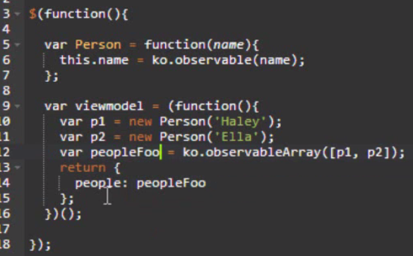
  + Revealing Module Pattern – pluralsight course “[Build HTML5 & JavaScript Apps with MVVM & Knockout](http://pluralsight.com/training/courses/TableOfContents?courseName=knockout-mvvm&highlight=john-papa_knockout-mvvm-m1*3,4,7,9,1,10,8!john-papa_knockout-mvvm-m6*11!john-papa_knockout-mvvm-m4*0!john-papa_knockout-mvvm-m3!john-papa_knockout-mvvm-m2!john-papa_knockout-mvvm-m5#knockout-mvvm-m1)”
  + Read and Set values using parentheses  
    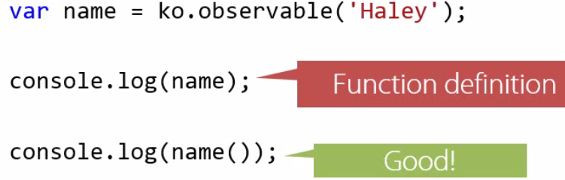  
    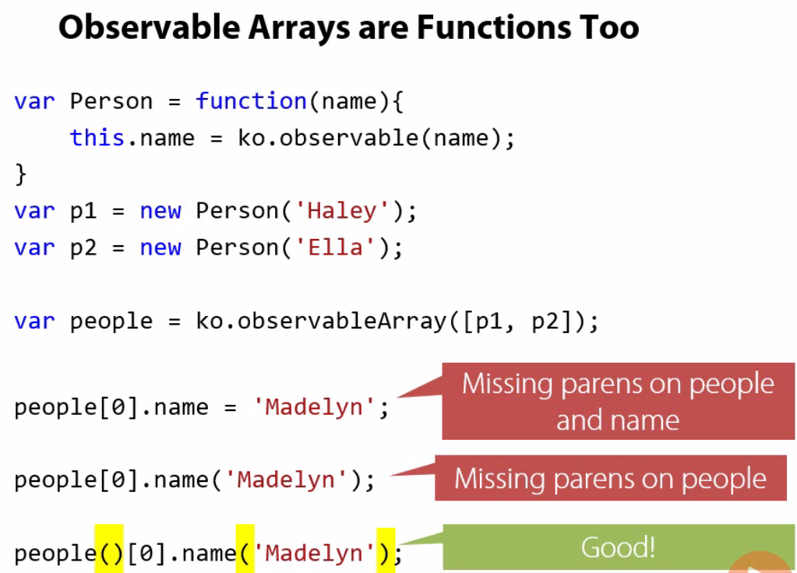
  + Use Parentheses:
    - Unwrapping observable function in code
    - Dive into objects with declarative binding
    - Right-Most Properties Don’t Require () in data-binding object.
  + sessions.html
  + Chrome Developer Tools:  
    There are several useful shortcuts for opening the DevTools:  
    Use Ctrl+Shift+I (or Cmd+Opt+I on Mac) to open the DevTools.  
    Use Ctrl+Shift+J (or Cmd+Opt+J on Mac) to open the DevTools and bring focus to the Console.  
    Use Ctrl+Shift+C (or Cmd+Shift+C on Mac) to open the DevTools in Inspect Element mode, or toggle Inspect Element mode if the DevTools are already open.